Hello professor this my answer for Homework 3

**1.**

1. Sc has an atomic number of 21 and is found in Sc3+. Sc3+ has a charge of +3, indicating that Sc has lost three electrons. Sc3+ has 21 – 3 = 18 electrons, which implies it has 21 – 3 = 18 electrons.

2. Cl– has an atomic number of 17 and is a halogen. Cl– has a charge of –1, indicating that it has acquired one electron. This indicates that the total number of electrons in Cl– is 17 + 1 = 18.

3. For K+, K has an atomic number of 19. K+ has a charge of +1, indicating that it has lost one electron. This indicates that the total number of electrons in K+ is 19 – 1 = 18.

4. The atomic number of Ca is 20 in Ca2+. Ca2+ carries a charge of +2, indicating that Ca has lost two electrons. This indicates that the total number of electrons in Ca2+ is 20 – 2 = 18.

5. S2–: S has an atomic number of 16. S2– has a –2 charge, indicating that S has acquired two electrons. This indicates that the total number of electrons in S2– is 16 + 2 = 18.

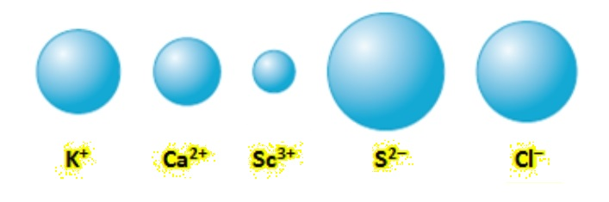

**2**.

Bond energies : C-H = 413 kJ/mol; C-O = 358 kJ/mol; O-H = 467 kJ/mol; C≡O = 107 kJ/mol

C-C = 347 kJ/mol; C=O = 745 kJ/mol;

The answer is : -20kJ

Student ID : 201923250 Name : Kobilov Ilkhomjon